Subject Supervisor:
Prof. Marian-Andrei Rizoiu
Lin Tian
Members:
Meiling Dong – 14537827
Jiwei Jiang – 25633037
Research Project
Analyzing Content Patterns on BiliBili and Bluesky
Table of Content

Introduction 2
Literature review 3
System Design 4
System Development 4
Data Collection 4
Anti-crawler 7
Multi-modal Data Integration 8
Data Forecast 9
Interactive tracking 11
Data visualization 13
Test and Result Acquisition 16
Conclusions and Future Work 17
References 19
Acknowledgement 20
Appendix 20

Introduction
With the rapid development of short videos and decentralized social networks, BiliBili and Bluesky represent emerging models of Chinese Internet and international social media platforms in content ecology and user behavior, respectively. This project aims to explore the characteristics, communication mechanism and interaction trend of user generated content on two emerging social platforms. The motivation of the project stems from the strong concern for understanding cross platform content trends, user interest patterns and their potential social impact in the current university research and industry needs.
The development of the prototype system of this project aims to build an automated and scalable cross platform data acquisition and analysis tool chain. The system uses Python as the main development language, combined with requests, pandas, Matplotlib and other open-source tools, and uses the unofficial BiliBili API (SocialSisterYi, 2020) and the official Bluesky API (Bluesky, 2025) to achieve accurate capture and structured storage of video and social dynamic content. At the same time, by reasonably designing the keyword screening mechanism and multi-stage crawler process, we can improve the efficiency and stability of data collection and provide high-quality raw data basis for subsequent analysis.
The project objectives include four stages of task completion: building a development environment and mastering the interface structure of the platform; Design research framework and formulate data acquisition scheme; Implement crawler tools and data processing pipelines, and conduct daily testing and optimization; Conduct in-depth analysis of the collected results, summarize the content mode and form a visual presentation.
The current project has completed the main part of the prototype development, and successfully realized the collection function of multi keyword content capture and interactive indicators. In addition, the system supports multilingual keyword combination (English, simplified and traditional Chinese), and the daily collected content is archived and analyzed around the "Belt and Road Initiative" and South Pacific topics. The preliminary test shows that the system has good scalability and analysis potential, and further enriches the data dimension, improves the visualization ability, and uses the integration of Streamlit to support more flexible data display and interactive analysis. Moreover, the project also includes voice extraction and transcription of BiliBili videos using Whisper Large V3 Turbo, enabling semantic understanding and multimodal analysis of video content. It incorporates lightweight prediction modules such as LinearRegression and LightGBM to analyze short-term interaction trends.

Literature review
In the field of video platforms, BiliBili is a typical community driven content ecosystem, with highly active users and unique interactive ways such as barrage, coin and collection (Wikipedia contributors, 2019). Existing studies have mostly focused on user behavior analysis, video recommendation mechanism and content dissemination path, such as assessment and analysis of the content and quality (Wang et al., 2024). Analysis of bullet screen content and emotional tendency (Wang, 2022). However, most of these studies are based on existing data sets and lack of continuous collection and update tracking of content. As a new decentralized social platform, Bluesky's content structure is closer to that of traditional social networks (such as twitter, forwarding, and tagging), but its technical architecture is based on open protocols, making its API interface more operable. At present, academic research is still in its infancy, and most of the relevant literatures focus on protocol design and platform Decentralization (Arroyo Machado et al., 2024). At the practical level, the research on automatic collection and content structured processing is not sufficient, especially the lack of supporting tools to support long-term content tracking.
The existing data acquisition research mostly uses real-time data capture, but it lacks the support for the actual engineering needs such as multi keyword, multi schedule video automatic update, exception handling and performance optimization. In addition, most data analysis systems fail to integrate visual interfaces for content insight expression, which limits the dissemination and interaction of analysis results.
In summary, there are two main deficiencies in the current research on data collection of content platforms: the lack of tools for simultaneous content collection of video and social platforms, and the lack of a tool system that supports keyword driven, automated updates, and data analysis and visualization. In order to better analyze the data of the two platforms, this project designed a keyword driven tool to support subsequent research on content patterns and interactive visualization, and analyzed the collected data.

System Design
This project builds an automated data collection system based on the virtual machine platform, which is used to track and analyze the content dynamics of BiliBili and Bluesky platforms every day, and automatically push the daily data summary and discovery through slack. Around the topics related to the "belt and road initiative", we have set up 9 theme keywords (belt and road initiative, one belt one road, maritime Silk Road, Silk Road Economic, Chinese investment, Chinese infrastructure projects, debt division, economic cooperation, strategic partnerships) and 4 location keywords (Papua New Guinea, Solomon Islands, Vanuatu, Fiji), which are arranged and combined in English, simplified Chinese and traditional Chinese respectively to form the daily keyword search pool and then we need to use this data to forecast future data.
Video content extraction is an important part of engagement. In order to achieve large-scale BiliBili audio content acquisition and voice transcribing processing, this project combines command-line tools, python multithreading programming technology, voice recognition model and data processing library to build a complete "audio extraction, transcribing and storage" process.

The file directory tree structure is as follows:
├── daily_snapshots
│ └── {date}
│ ├── active_videos_{date}.csv/xlsx/json # Active video, including updated information
│ ├── removed_videos_{date}.csv/xlsx/json # Dead video historical data removed on that day
│ ├── new_videos_{date}.csv/xlsx/json # Video that first entered the tracking pool │ └── daily_videos_{date}.csv/xlsx/json # Full video collection
├── tracking_pool.json # Global tracking pool, updated daily
└── removed_videos.json # Remove all history videos and add records each time

In this database building and subsequent data maintenance, the collected videos are updated daily, the changes of interactive data are recorded, the "dead videos" without growth in 72 hours are eliminated, the new videos of relevant keywords published within 24 hours are added, and the structured result files are output for subsequent analysis and visualization.
In this project, two interactive data visualization systems are constructed for Bluesky post analysis and BiliBili video tracking analysis, both of which use the Streamlit framework.

System Development

Data Collection
By calling the API interface of the platform, the system can capture content by keyword combination, including metadata such as video title, interactive indicators (likes, forwards, comments, etc.), upload time and creator information. All capture results are archived into a structured directory by date for visual analysis and historical tracking.
In order to maintain the timeliness and accuracy of data, the system follows the following automation rules: remove inactive content: if a content has no interactive growth (like, comment, share, etc.) within 72 consecutive hours, it will be judged as invalid content and removed from the tracking pool; add content of the day: capture the latest content released within nearly 24 hours every day to ensure the representativeness of the sample; continuous content tracking: continuously update interactive indicators for all active content for subsequent trend prediction and visual presentation.
The following examples display how to get post contents and what data we retrieved.
1. # Search posts
2. def search_posts(query, token, limit=200):
3. url = f"{BASE_URL}/app.bsky.feed.searchPosts"
4. headers = {"Authorization": f"Bearer {token}"}
5. params = {"q": query, "limit": 50}
6. posts = []
7. cursor = None
8. while len(posts) < limit:
9. if cursor:
10. params["cursor"] = cursor
11. response = requests.get(url, headers=headers, params=params)
12. if response.status_code != 200:
13. print(f"❌ Search error: {query}")
14. break
15. data = response.json()
16. batch = data.get("posts", [])
17. if not batch:
18. break
19. posts.extend(batch)
20. cursor = data.get("cursor")
21. if not cursor:
22. break
23. time.sleep(random.uniform(0.05, 0.2))
24. return posts[:limit]
25.

1. {
2. "Keyword":"Belt and Road Initiative (BRI)",
3. "Title":"“一带一路”网宣片《Belt and Road》英文版",
4. "Uploader":"上海外国语大学",
5. "Views":144959,
6. "Likes":7298,
7. "Shares":3895,
8. "Favorites":9377,
9. "Coins":765,
10. "Comments":64,
11. "Danmaku":0,
12. "Link":"https:\/\/www.bilibili.com\/video\/BV1My4y1K7v9",
13. "UID":321364597,
14. "Published Date":"18-10-2023 06:00:00",
15. "Send Time":"2023-10-18 03:49:30",
16. "Duration":"2m 33s",
17. "Tags":"英文, 一带一路, 上海外国语大学, SISU",
18. "Description":"“一带一路”网宣片《Belt and Road》英文版出品｜人民日报译制｜上海外国语大学法语｜陆焕 郑理俄语｜杜韵莎 张嘉辉 Maxim Shishkov 许宏西班牙语｜张礼骏 Jesús Rodríguez Manzano 阿拉伯语｜周放 Mahmoud Soliman Ahmed Zidan 陆怡玮后期制作｜阮骏 陈秋余编辑｜牟家慧统筹｜顾忆青 牟家慧",
19. "Gender":"保密",
20. "Level":5
21. },
22.

The core of the system completes the HTTP interface request based on the requests library. For getting requests, the program simulates user behavior by constructing request parameters and headers to bypass simple anti crawler detection. For example:
1. response = requests.get(url, headers=headers, params=params)
The capture of both platforms requires identity authentication. Bluesky has a special official authentication channel, and BiliBili can use the registered account password to obtain access to sensitive data.
The following demonstrates the authentication approach required for data access:
1. # Get token
2. def get_token(username, app_password):
3. url = f"{BASE_URL}/com.atproto.server.createSession"
4. payload = {
5. "identifier": username,
6. "password": app_password
7. }
8. response = requests.post(url, json=payload)
9. if response.status_code == 200:
10. data = response.json()
11. token = data.get("accessJwt")
12. if token:
13. print("✅ Successfully obtained token.")
14. return token
15. print("❌ Failed to get token.")
16. return None
1. # 🍪 Cookies (Update if expired)
2. cookies = {
3. "SESSDATA": "this is my Bilibili cookie",
4. "bili_jct": "this is my Bilibili cookie",
5. "DedeUserID": "this is my Bilibili cookie"
6. }

The keyword combination described:
1. topic_keywords = [
2. "Belt and Road Initiative (BRI)", "One Belt One Road (OBOR)", "Maritime Silk Road",
3. "Silk Road Economic Belt", "Chinese investment", "Chinese infrastructure projects",
4. "Debt diplomacy", "Economic cooperation", "Strategic partnerships",
5. "一带一路倡议 (BRI)", "一带一路 (OBOR)", "海上丝绸之路", "丝绸之路经济带",
6. "中国投资", "中国基础设施项目", "债务外交", "经济合作", "战略伙伴关系",
7. "一帶一路倡議", "一帶一路", "海上絲路", "絲路經濟帶",
8. "中國投資", "中國基礎建設項目", "債務外交", "經濟合作", "戰略夥伴關係"
9. ]
10.
11. location_keywords = [
12. "Papua New Guinea (PNG)", "Solomon Islands (SI)", "Vanuatu", "Fiji",
13. "巴布亚新几内亚 (PNG)", "所罗门群岛 (SI)", "瓦努阿图", "斐济",
14. "巴布亞紐幾內亞 (PNG)", "所羅門群島 (SI)", "瓦努阿圖", "斐濟"
15. ]
16.
17. keywords_topic_only = topic_keywords
18. keywords_location_only = location_keywords
19. keywords_topic_location = [f"{t} {l}" for t in topic_keywords for l in location_keywords]
20. keywords = keywords_topic_only + keywords_location_only + keywords_topic_location
21. print(f"🔢 Total keywords: {len(keywords)}")
22.

In this project, the collected content data (video information, comments, user information, etc.) are exported to three mainstream formats: csv, xlsx and json. Using multi format data storage not only enhances the versatility and flexibility of the system, but also provides convenience for subsequent analysis, display and sharing.
1. # Export collected video metadata to Excel/CSV/JSON
2. df = pd.DataFrame(all_video_records, columns=[
3. "Keyword", "Title", "Uploader", "Views", "Likes", "Shares", "Favorites", "Coins", "Comments", "Danmaku",
4. "Link", "UID", "Published Date", "Send Time", "Duration", "Tags", "Description",
5. "Gender", "Level"
6. ])
7. df = df.applymap(clean_illegal_chars)
8. df.to_excel("bilibili_video_info.xlsx", index=False)
9. df.to_csv("bilibili_video_info.csv", index=False)
10. df.to_json("bilibili_video_info.json", force_ascii=False, orient='records', indent=4)
11. print("📄 Excel, CSV and JSON files saved for video metadata.")

1. posts_csv_data = [{k: v for k, v in row.items() if k in post_csv_headers} for row in all_posts]
2.
3. write_json(os.path.join(output_dir, f"post{now_str}.json"), all_posts)
4. write_csv(os.path.join(output_dir, f"post{now_str}.csv"), posts_csv_data, post_csv_headers)
5. write_excel(os.path.join(output_dir, f"post{now_str}.xlsx"), all_posts, post_csv_headers)
6.
7. comment_csv_headers = ["Source Post", "Comment Content", "Comment Like Count", "Comment Time", "Comment Author"]
8.
9. write_json(os.path.join(output_dir, f"comment{now_str}.json"), all_comments)
10. write_csv(os.path.join(output_dir, f"comment{now_str}.csv"), all_comments, comment_csv_headers)
11. write_excel(os.path.join(output_dir, f"comment{now_str}.xlsx"), all_comments, comment_csv_headers)

Anti-crawler
The biggest difficulty we encountered in the project capture phase of this study was BiliBili's anti-crawler mechanism. Any large number of consecutive unauthorized data fetches will start this mechanism, resulting in empty fetched data. To solve this problem, we used the camouflage head mentioned above. As shown in the figure, we add various simulation elements to the camouflage header to confuse the anti-crawler mechanism. In addition, we also avoid anti crawlers by imitating the behavior of human browsing the web by limiting the access time. The following two figures show the camouflage header and time simulation we used respectively.
1. # Request headers
2. headers = {
3. "User-Agent": "Mozilla/5.0 (Windows NT 10.0; Win64; x64) AppleWebKit/537.36 Chrome/119.0.0.0 Safari/537.36",
4. "Referer": "https://www.bilibili.com/",
5. "Origin": "https://www.bilibili.com",
6. "Accept": "application/json, text/plain, */*",
7. "Accept-Language": "zh-CN,zh;q=0.9",
8. "X-Requested-With": "XMLHttpRequest",
9. "Connection": "keep-alive"
10. }
11.

1. def human_sleep(min_sec=0.5, max_sec=2.5):
2. base_sleep = random.uniform(min_sec, max_sec)
3. if random.random() < 0.1:
4. base_sleep += random.uniform(2, 5)
5. time.sleep(base_sleep)
6.

Multi-modal Data Integration
In this project, yt-dlp is used to extract audio stream from BiliBili video page. The Whisper Large V3 Turbo model is used to convert language into text for summarizing video content. The modified model has high recognition accuracy, supports segmented reasoning, and is compatible with GPU accelerated execution (Openai, 2022). By integrating the above tools, the project has built an efficient, stable and scalable audio data processing process, which not only supports daily batch processing, but also provides a solid foundation for semantic analysis and multimodal research. The tool selection takes into account the command line performance, python ease of use and the advancement of the deep learning model, and fully meets the dual needs of engineering practice and research exploration. Code snippets demonstrating the audio processing pipeline are shown below:
1. # transcribe
2. def transcribe(filename):
3. bv = os.path.splitext(filename)[0]
4. audio_path = os.path.join(audio_dir, filename)
5. if os.path.getsize(audio_path) < 100 * 1024:
6. with lock:
7. task_status.append({"file": filename, "status": "skipped", "error": "file too small"})
8. return None
9.
10. start_time = time.time()
11. for attempt in range(3):
12. try:
13. audio, sr = librosa.load(audio_path, sr=16000)
14. segment_duration = 30
15. segment_samples = segment_duration * sr
16. num_segments = int(np.ceil(len(audio) / segment_samples))
17.
18. full_text = ''
19. for i in range(num_segments):
20. segment = audio[i * segment_samples: (i + 1) * segment_samples]
21. inputs = processor(segment, sampling_rate=16000, return_tensors="pt")
22. inputs = {k: v.to(device, dtype=torch.float16) if v.dtype == torch.float32 else v.to(device) for k, v in inputs.items()}
23. with torch.no_grad():
24. generated_ids = model.generate(inputs["input_features"], max_new_tokens=128)
25. text = processor.batch_decode(generated_ids, skip_special_tokens=True)[0]
26. full_text += text.strip() + ' '
27.
28. with open(os.path.join(output_txt_dir, f"{bv}.txt"), "w", encoding="utf-8", errors="ignore") as f_out:
29. f_out.write(full_text.strip())
30.
31. with lock:
32. with open(transcribed_log, "a", encoding="utf-8", errors="ignore") as f_log:
33. f_log.write(bv + "\n")
34. data.append({"BV Number": bv, "Transcript": full_text.strip()})
35. task_status.append({"file": filename, "status": "success", "error": ""})
36. progress["processed"] += 1
37.
38. duration = time.time() - start_time
39. print(f"🕒 {filename} timecost：{duration:.2f} s")
40. return bv
41. except Exception as e:
42. err_msg = str(e)
43. if attempt == 2:
44. with lock:
45. task_status.append({"file": filename, "status": "failed", "error": err_msg})
46. with open(error_log, "a", encoding="utf-8", errors="ignore") as f_err:
47. f_err.write(f"{filename}: {err_msg}\n")
48. time.sleep(2)
49. return None

1. # sleep check
2. def download_worker():
3. while not q.empty():
4. while pause_event.is_set():
5. time.sleep(1)
6.
7. try:
8. idx, total, bv, link = q.get_nowait()
9. except Exception:
10. break
11.
12. out_file = os.path.join(output_dir, f'{bv}.m4a')
13. print(f'▶️ downloading {idx}/{total} → BV: {bv}')
14.
15. for attempt in range(3):
16. try:
17. command = f'yt-dlp -f ba --user-agent "Mozilla/5.0 (Windows NT 10.0; Win64; x64)" -o "{out_file}" "{link}"'
18. result = subprocess.run(command, shell=True, capture_output=True, text=True)
19. if result.returncode == 0:
20. with lock:
21. with open(finished_file, 'a', encoding='utf-8') as f_done:
22. f_done.write(bv + '\n')
23. print(f'✅ : {bv}')
24. break
25. elif '403' in result.stderr or '404' in result.stderr:
26. with lock:
27. with open(invalid_file, 'a', encoding='utf-8') as f_bad:
28. f_bad.write(bv + '\n')
29. print(f'❌ （{bv}）: {link}')
30. break
31. else:
32. print(f'⚠️ {attempt+1} false: {bv}')
33. time.sleep(random.uniform(5, 10))
34. except Exception as e:
35. print(f'❌ error: {bv} → {str(e)}')
36. time.sleep(random.uniform(1, 2))
37. q.task_done()
38.

Data Forecast
For BiliBili, although the number of days to collect data is small, the total amount of data is huge, so it is a good choice to use the lightweight prediction module of LinearRegression model to predict. The model is simple to implement, high computational efficiency and strong interpretability. It is suitable for the prediction of short-term growth trend, and can run without a large number of historical data training. Below is an example of using LinearRegression model:
1. if predict_days and len(df) >= 3:
2. df = df[[x, y]].dropna().reset_index(drop=True)
3. df['Day_Num'] = range(len(df))
4. X = df[['Day_Num']]
5. y_vals = df[y]
6.
7. try:
8. model = LinearRegression()
9. model.fit(X, y_vals)
10.
11. future_X = pd.DataFrame({'Day_Num': range(len(df), len(df) + predict_days)})
12. future_dates = [df[x].iloc[-1] + timedelta(days=i + 1) for i in range(predict_days)]
13. future_y = model.predict(future_X)
14.
15. full_pred_dates = [df[x].iloc[-1]] + future_dates
16. full_pred_y = [df[y].iloc[-1]] + list(future_y)
17.
18. fig.add_trace(go.Scatter(
19. x=full_pred_dates,
20. y=full_pred_y,
21. mode='lines+markers',
22. name=f"Prediction +{predict_days}d",
23. line=dict(dash='dot', color='#ff7f0e')
24. ))
25. except Exception as e:
26. st.warning(f"Prediction failed: {e}")

In the part of Bluesky of the project, the lightGBM (light gradient boosting machine) model is adopted in this project. Due to the lack of data, the built-in mechanism of lightGBM for processing missing values and classification features is very important. The model has high prediction accuracy and fast training speed, and is suitable for the time series change of nonlinear trend and has good expansibility. Below is an example of using and training lightGBM:
1. # TRAIN
2. def train_and_predict(df):
3. results = []
4. grouped = df.groupby("Query")
5. predict_date = df["Date"].max() + timedelta(days=1)
6. now = datetime.now().strftime("%Y-%m-%d %H:%M:%S")
7.
8. for query, group in grouped:
9. daily_stats = group.groupby("Date").agg(Post_Count=("Engagement", "count"),
10. Total_Engagement=("Engagement", "sum"))
11. daily_stats = daily_stats[daily_stats["Post_Count"] >= 20].copy()
12. if len(daily_stats) < 5:
13. continue
14.
15. daily_stats = daily_stats.reset_index()
16. daily_stats["Date"] = pd.to_datetime(daily_stats["Date"])
17. daily_stats["day"] = (daily_stats["Date"] - daily_stats["Date"].min()).dt.days
18.
19. X = daily_stats[["day"]]
20. y = daily_stats["Total_Engagement"]
21. X_train, X_test, y_train, y_test = train_test_split(X, y, test_size=0.2, shuffle=False)
22.
23. model = lgb.LGBMRegressor()
24. model.fit(X_train, y_train)
25.
26. next_day = daily_stats["day"].max() + 1
27. pred = model.predict([[next_day]])[0]
28.
29. results.append({
30. "Query": query,
31. "Predict Date": predict_date.strftime("%Y-%m-%d"),
32. "Predicted Engagement": int(pred),
33. "Last N Days Used": len(daily_stats),
34. "Model Time": now
35. })
36. return pd.DataFrame(results)

Interactive tracking
Taking the work of BiliBili part as an example, the main control script runs automatically and regularly every day, including: loading the daily new video list; Merge into tracking pool `tracking_pool.json '; update interactive history, including fields such as like, forward, coin, and collection.
The following figure shows the tracking pool retrieved data sample:
1. {
2. "version": 2,
3. "last_updated": "2025-05-09T20:40:54.724581",
4. "videos": {
5. "BV1bxffYTEUi": {
6. "fields": {
7. "Keyword": "債務外交 斐济",
8. "Title": "【授权汉化】存在租借金库里的斐济杯被全部盗走的俊达萌",
9. "Link": "https://www.bilibili.com/video/BV1bxffYTEUi",
10. "Uploader": "月夜喵",
11. "Upload_Date": "2025-01-25 11:08:09",
12. "Views": 255971,
13. "Likes": 44374,
14. "Shares": 2869,
15. "Favorites": 8636,
16. "Coins": 866,
17. "Comments": 552,
18. "Danmaku": 317,
19. "Duration": "2m 45s",
20. "Tags": "中文字幕, 虚拟偶像, 日语, 搞笑, VOICEVOX, 俊达萌",
21. "Description": "https://www.youtube.com/watch?v=XFO2HkeHswo原作者：あぎりさんぽ授权汉化：月夜喵ヘこへこ[合成音声]VOICEVOX：ずんだもんVOICEVOX：春日部つむぎVOICEVOX：四国めたんVOICEVOX：WhiteCULVOICEVOX：青山龍星VOICEVOX：栗田まろん",
22. "Gender": "",
23. "Level": ""
24. },
25. "first_seen": "2025-04-12",
26. "stats_history": [
27. {
28. "date": "2025-04-12",
29. "stats": {
30. "Views": 248208,
31. "Likes": 44107,
32. "Shares": 2817,
33. "Favorites": 8599,
34. "Coins": 860,
35. "Comments": 542,
36. "Danmaku": 308
37. }
38. },
39. {
40. "date": "2025-04-13",
41. "stats": {
42. "Views": 250531,
43. "Likes": 44188,
44. "Favorites": 8603,
45. "Shares": 2835,
46. "Comments": 544,
47. "Danmaku": 314,
48. "Coins": 862
49. }
50. },
51. {
52. "date": "2025-04-14",
53. "stats": {
54. "Views": 250715,
55. "Likes": 44191,
56. "Favorites": 8604,
57. "Shares": 2836,
58. "Comments": 545,
59. "Danmaku": 314,
60. "Coins": 862
61. }
62. },
In addition, this process also includes the judgment of dead videos: videos without interactive growth or off the shelf for 72 consecutive hours for various reasons.
The following figure is an example of removing dead video data:
1. {
2. "version": 1,
3. "removed": [
4. {
5. "bvid": "BV1ZP4y1E7Sf",
6. "removed_at": "2025-05-02T01:25:54.409331",
7. "reason": "inactive_3days_nogrowth",
8. "last_stats": {
9. "Keyword": "中国基础设施项目 Papua New Guinea (PNG)",
10. "Title": "广州海珠湿地，国际风景园林师联合会（IFLA）公布了2021年亚非中东地区风景园林奖获奖名单，海珠湿地摘得两项大奖",
11. "Link": "https://www.bilibili.com/video/BV1ZP4y1E7Sf",
12. "Uploader": "新生活环保",
13. "Upload_Date": "09-01-2022 03:28:31",
14. "Views": 63,
15. "Likes": 1,
16. "Shares": 0,
17. "Favorites": 0,
18. "Coins": 0,
19. "Comments": 0,
20. "Danmaku": 0,
21. "Duration": "0m 55s",
22. "Tags": "风景, 自然生态, 广州海珠湿地, 湿地公园, 生物多样性, 湿地, 风景园林, IFLA, 海珠湿地, 打卡挑战",
23. "Description": "广州海珠湿地，国际风景园林师联合会（IFLA）公布了2021年亚非中东地区风景园林奖获奖名单，海珠湿地摘得两项大奖。“海珠湿地生物多样性保护修复工程项目”分别荣获“2021年国际风景园林师联合会亚非中东地区奖（IFLA AAPME）”自然生态类别和开放公园类别的杰出奖（Outstanding Award），杰出奖为这两个类别的最高奖。转载来源：广视频。广州市新生活环保促进会，让河流与城市共荣，让城市可持续发展联系：小新微信号gepxiaoxin，官方邮箱gep2013@163.com",
24. "Gender": "",
25. "Level": ""
26. },
27. "history_count": 3
28. },

Data visualization
Streamlit is a python oriented declarative web application development tool, which enables developers to quickly build a data visualization interface with rich functions and strong interactivity without mastering front-end skills. It can be seen from the two examples of seedata.py and streamlit.py that Streamlit supports a variety of interface components such as sidebar filtering, date selector, tab, and expandable panel, providing users with an efficient and smooth data interaction experience. Users can quickly build a data visualization interface as shown in the following figure.
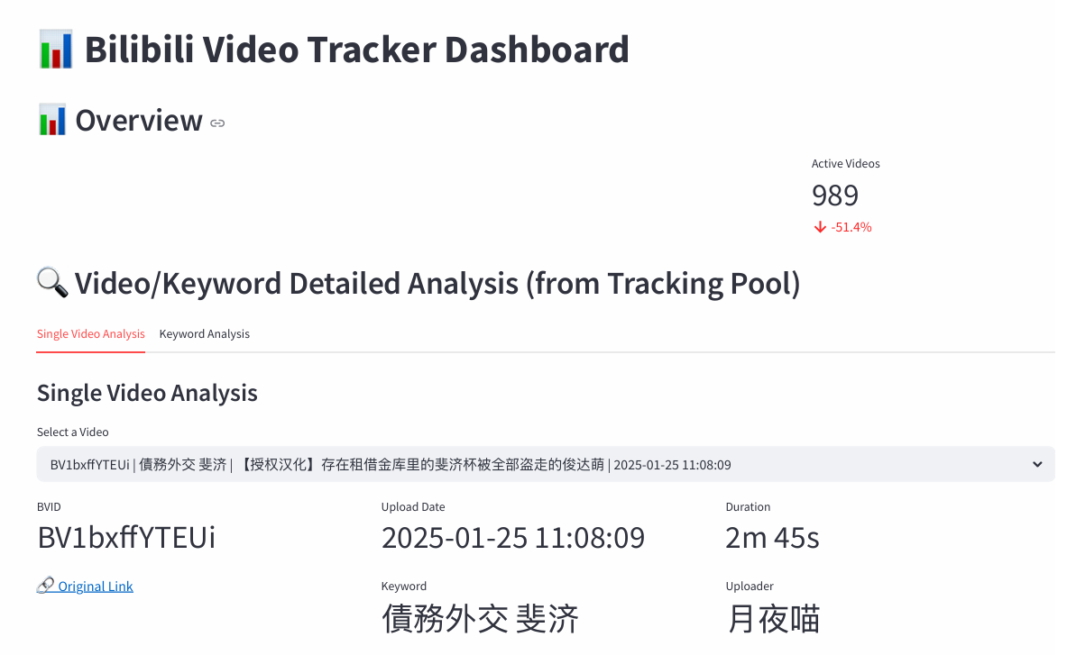

One advantage of Streamlit is its state caching mechanism, such as the @st.cache_data decorator used in the code, which can significantly improve the data loading performance, avoid repeated reading of large Excel or CSV files, and improve the system response speed. In addition, Streamlit natively supports the plot chart library, which can easily achieve rich visualization effects such as pie chart, histogram, broken line chart, thermal chart, etc. the chart has a responsive interactive function, which helps users to explore the characteristics of data trends, outliers and keyword distribution. The following figure is an example of using @st.cache_data decorator in the Bluesky part.
1. @st.cache_data
2. def load_all_data(folder_path):
3. dfs = []
4. for file in os.listdir(folder_path):
5. if file.startswith('post') and file.endswith('.xlsx'):
6. df = pd.read_excel(os.path.join(folder_path, file))
7. ts = file.replace('post', '').replace('.xlsx', '')
8. df['Capture Time'] = datetime.strptime(ts, "%Y%m%d%H%M")
9. dfs.append(df)
10. return pd.concat(dfs, ignore_index=True) if dfs else pd.DataFrame()
11.

Furthermore, Streamlit provides a highly modular development method. For example, in the BiliBili dashboard, functions such as plot_lineplot() and show_growth_metrics() encapsulate the logic of LinearRegression prediction and growth trend analysis, making the visualization system have lightweight trend prediction ability. On the Bluesky dashboard, Streamlit allows developers to easily filter and display real-time interactive data based on keywords and time, and visually present it through charts. The following illustrations are some of the charts built this time.
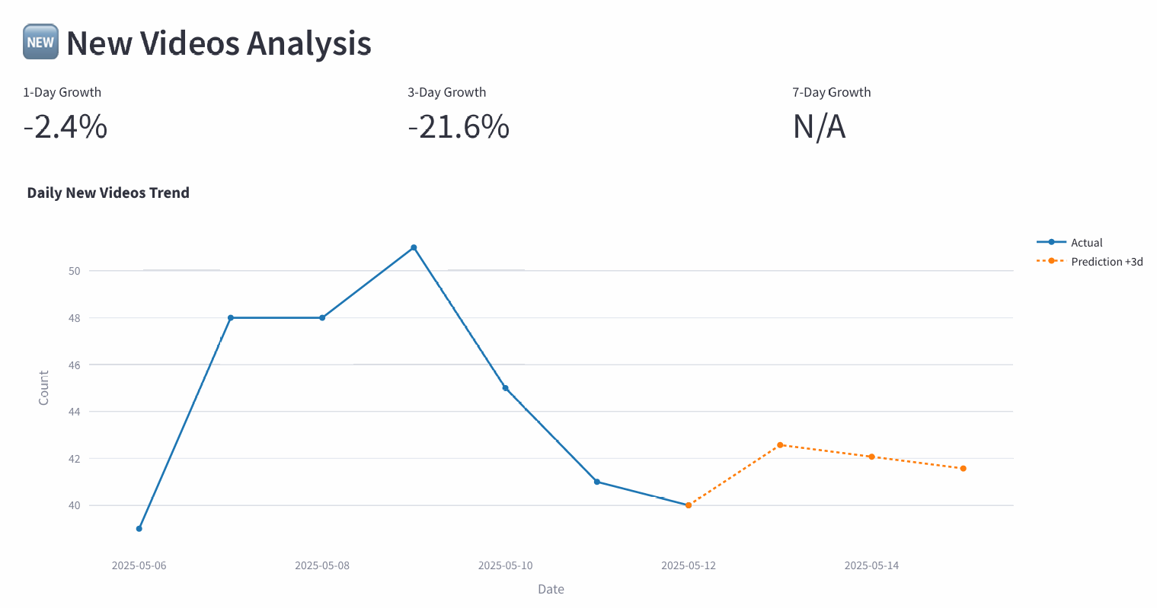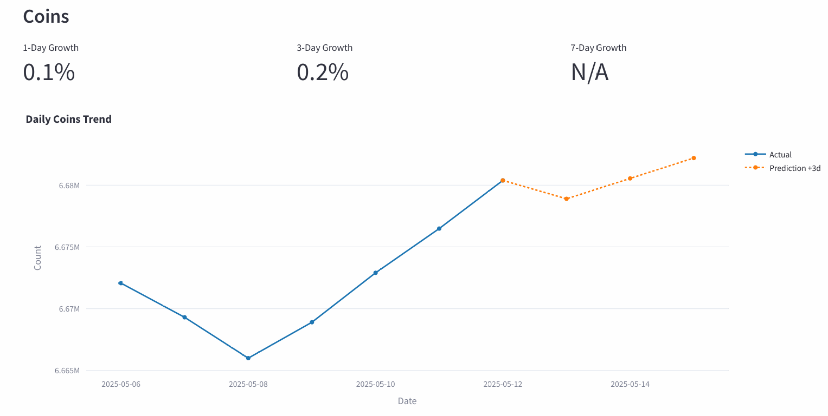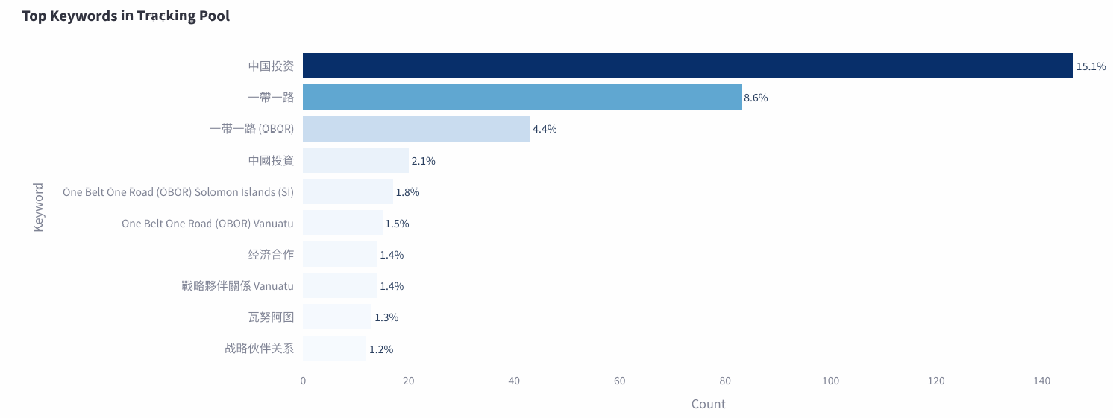

Test and Result Acquisition
Since the end of the software development, the software has been running automatically in the background of the virtual machine every day and generated relevant files. Take Bluesky as an example. The following figure shows some of the data we collected:
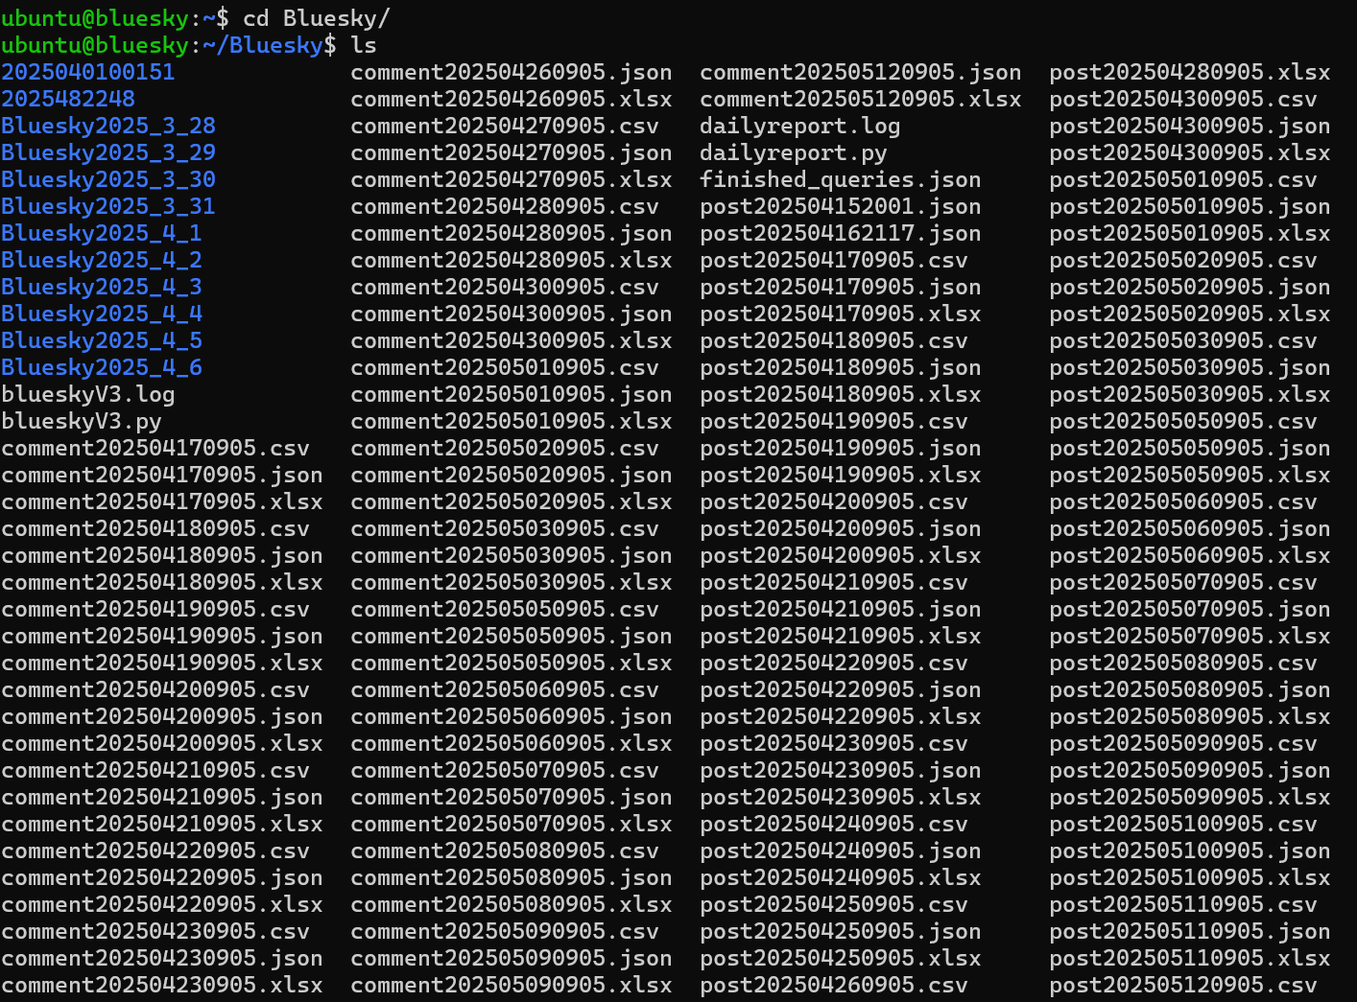
Each file contains all relevant data, as shown in the figure:
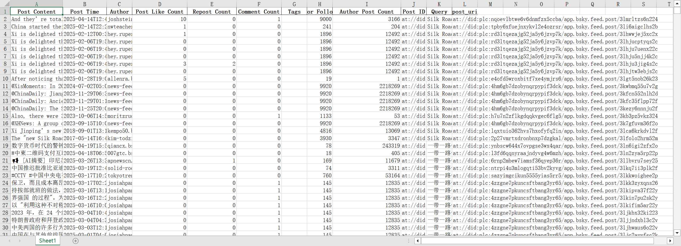
Daily reports will also be generated and shared on slack, if there are obvious errors in the data during the process, we will repair them accordingly:
BiliBili Daily Tracking Table
Date | Daily videos fetched | Newly added videos today | Removed inactive videos | Active videos today | Final tracked videos | Total normalized keywords
2025/4/15 | 10631 | 43 | 1372 | 2768 | 9259 | 346 / 351
2025/4/16 | 9257 | 36 | 1460 | 2035 | 7833 | 346 / 351
2025/4/17 | 7902 | 69 | 877 | 2035 | 7025 | 346 / 351
2025/4/18 | 7069 | 45 | 611 | 1561 | 6458 | 344/ 351
2025/4/19 | 6503 | 45 | 465 | 1442 | 6038 | 343/ 351
2025/4/20 | 6083 | 45 | 349 | 1365 | 5734 | 343/ 351
2025/4/21 | 5779 | 46 | 278 | 1315 | 5501 | 343/ 351
2025/4/22 | 5548 | 47 | 233 | 1271 | 5315 | 342/ 351
2025/4/23 | 5353 | 40 | 233 | 1213 | 5120 | 342/ 351
2025/4/24 | 5163 | 43 | 207 | 1161 | 4956 | 342/ 351
2025/4/25 | 4987 | 31 | 196 | 1114 | 4791 | 342/ 351
2025/4/26 | 4824 | 34 | 157 | 1097 | 4667 | 342/ 351
2025/4/27 | 4716 | 53 | 124 | 1077 | 4592 | 340/ 351
2025/4/28 | 4629 | 38 | 126 | 1061 | 4503 | 340/ 351
2025/4/29 | 4550 | 47 | 102 | 1057 | 4448 | 340/ 351
2025/4/30 | 4484 | 36 | 113 | 1037 | 4371 | 340/ 351
2025/5/1 | 4405 | 46 | 106 | 1032 | 4299 | 339/ 351
2025/5/2 | 4331 | 32 | 97 | 1016 | 4234 | 338/ 351
2025/5/3 | 4270 | 36 | 110 | 989 | 4160 | 337/ 351
2025/5/4 | 4195 | 35 | 3175 | 981 | 1020 | 242 / 351
2025/5/5 | 1037 | 17 | 65 | 917 | 972 | 239 / 351
2025/5/6 | 1009 | 39 | 44 | 908 | 965 | 238/ 351
2025/5/7 | 1010 | 48 | 38 | 890 | 972 | 232 / 351
2025/5/8 | 1019 | 48 | 34 | 891 | 985 | 232 / 351
2025/5/9 | 1032 | 51 | 39 | 895 | 993 | 231 / 351
2025/5/10 | 1031 | 45 | 42 | 898 | 989 | 229 / 351

Bluesky Daily Tracking Table
Date | Newly added posts today | Active posts today | Posts no activity | Final tracked posts
2025/4/16 | 498 | 52 | 3304 | 3854
2025/4/17 | 192 | 48 | 3619 | 3859
2025/4/18 | 205 | 52 | 3607 | 3864
2025/4/19 | 140 | 43 | 3611 | 3794
2025/4/20 | 169 | 33 | 3669 | 3871
2025/4/21 | 158 | 40 | 4382 | 3880
2025/4/22 | 142 | 49 | 3684 | 3875
2025/4/23 | 267 | 35 | 3600 | 3902
2025/4/24 | 257 | 51 | 3605 | 3913
2025/4/25 | 205 | 36 | 3559 | 3800
2025/4/26 | 301 | 27 | 3597 | 3925
2025/4/27 | 88 | 46 | 3793 | 3927
2025/4/28 | 108 | 27 | 3791 | 3926
2025/5/1 | 250 | 50 | 3649 | 3649
2025/5/2 | 172 | 40 | 3747 | 3959
2025/5/3 | 216 | 34 | 3713 | 3963
2025/5/6 | 204 | 39 | 3723 | 3966
2025/5/7 | 228 | 38 | 3707 | 3973
2025/5/8 | 188 | 43 | 3750 | 3981
2025/5/9 | 199 | 36 | 3745 | 3989
2025/5/10 | 217 | 42 | 3735 | 3994

Conclusions and Future Work
This project has successfully designed and implemented a set of scalable and automated cross platform content acquisition, audio transcribing and data visualization system, mainly for BiliBili and Bluesky platforms. Through the integration of Python language and a variety of open-source tools, the system can achieve large-scale, multilingual keyword driven content capture and analysis. The project has been completed: daily content capture and structured; extraction of BiliBili audio by YT DLP tool and high-precision voice transcribing; support for subsequent semantic content analysis; interactive visualization dashboard based on Streamlit, interactive prediction based on LinearRegression and lightGBM model. Although the project has initially realized the functions of cross platform data collection, voice transcription and interactive visualization, there are still some limitations in practical application: BiliBili's anti-crawler mechanism is strong, relying on simulated user behavior to bypass, and there is a risk of being banned. Although Bluesky's API is officially supported, its functions are still under development, and some data fields are still unstable. The current analysis is mainly based on public interactive data such as likes, forwards, comments, etc., but fails to cover the user's complete behavior trajectory, such as viewing duration, jump out rate and other deeper interactive data. Overall, the system is not only an efficient data collection tool, but also a research platform for media impact research, content propagation path analysis and cross platform dialogue observation. It provides a reusable and extensible framework for long-term exploration in the fields of computational social sciences, digital media research and international relations. In the future, we will try to introduce transformer-based time series models such as Informer, Autoformer and TimeSeries Transformer to capture the long-term dependence characteristics in interactive trends and improve the accuracy of medium and long-term prediction. We will try to conduct user behavior path analysis, and mine more complex communication paths, influence networks and community evolution mechanisms.

References
Arroyo-Machado, W., Robinson-Garcia, N., & Torres-Salinas, D. (2024). Are there stars in Bluesky? A comparative exploratory analysis of altimetric mentions between X and Bluesky. ArXiv (Cornell University). https://doi.org/10.5281/zenodo.14290752
Bluesky. (2025). Bluesky Documentation | Bluesky. Bsky.app. https://docs.bsky.app
OpenAI. (2022). Introducing Whisper. Openai.com. https://openai.com/index/whisper/
SocialSisterYi. (2020). GitHub - SocialSisterYi/bilibili-API-collect: 哔哩哔哩-API收集整理【不断更新中....】. GitHub. https://github.com/SocialSisterYi/bilibili-API-collect
Wang, M., Yao, N., Wang, J., Chen, W., Ouyang, Y., & Xie, C. (2024). Bilibili, TikTok, and YouTube as sources of information on gastric cancer: assessment and analysis of the content and quality. BMC Public Health, 24(1). https://doi.org/10.1186/s12889-023-17323-x
Wang, R. (2022). Community-Building on Bilibili: The Social Impact of Danmu Comments. Media and Communication, 10(2), 54–65. https://doi.org/10.17645/mac.v10i2.4996
Wikipedia Contributors. (2019, November 7). Bilibili. Wikipedia; Wikimedia Foundation. https://en.wikipedia.org/wiki/Bilibili

Acknowledgement
Thanks for Prof. Marian-Andrei Rizoiu & Lin. They accepted the invitation as our supervisor, and they regularly organized video conferences every week, carefully answered our questions and helped us sort out our ideas.

Appendix
Below is the GitHub link for all the code of this project: JiweiJ/Research-Project: Research Project.

